School of Computer Science and Artificial Intelligence

Lab Assignment 8.5

Name of Student : Gunturu Devi Prasad
Enrollment No. : 2303A51538
Batch No. : 22

Task Description #1 (Username Validator – Apply AI in Authentication Context) • Task: Use AI to generate at least 3 assert test cases for a function is_valid_username and then implement the function using Test-Driven Development principles.
• Requirements:
- Username length must be between 5 and 15 characters. o Must contain only alphabets and digits. o Must not start with a digit.
- No spaces allowed. Example Assert Test Cases: assert is_valid_username("User123") == True assert is_valid_username("12User") == False assert is_valid_username("Us er") == False Expected Output #1:
- Username validation logic successfully passing all AI- generated test cases.

Prompt
Write a Python program that creates a function to verify whether a username is valid according to the following rules:
- The username length must be between 5 and 15 characters.
- It should contain only letters and numbers.
- The first character must not be a number.
- Spaces are strictly not permitted.
Include multiple assert test cases that cover all possible scenarios such as:
- Valid username
- Username shorter than 5 characters
- Username longer than 15 characters
- Username starting with a digit
- Username containing spaces
- Username containing special characters
Display the output showing that all test cases have successfully passed.
Code:-
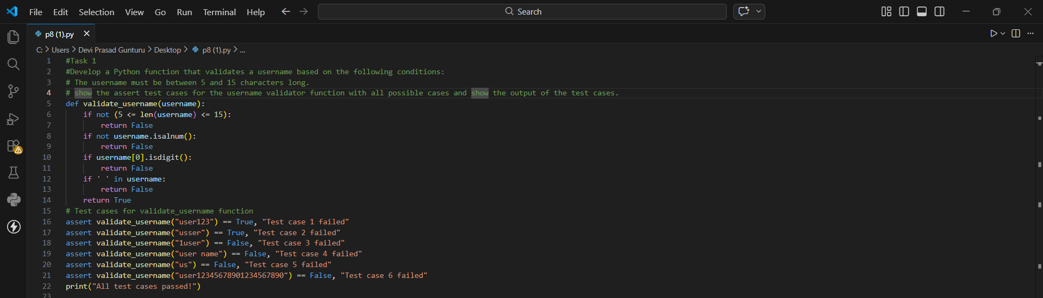
Output:-
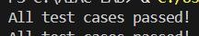
Task Description #2 (Even–Odd & Type Classification – Apply
AI for Robust Input Handling)
- Task: Use AI to generate at least 3 assert test cases for a
function classify_value(x) and implement it using conditional logic and loops.
- Requirements:
- If input is an integer, classify as "Even" or "Odd".
- If input is 0, return "Zero".
- If input is non-numeric, return "Invalid Input".
Example Assert Test Cases:
assert classify_value(8) == "Even" assert classify_value(7) == "Odd" assert classify_value("abc") == "Invalid Input" Expected Output #2:
- Function correctly classifying values and passing all test cases.
Prompt:-
write a python program to classify Even and Odd numbers and generate 3 assert test cases for the function classify number and if number given is 0 return zero and if given character return invalid input. show the output of the test cases.
Code:-
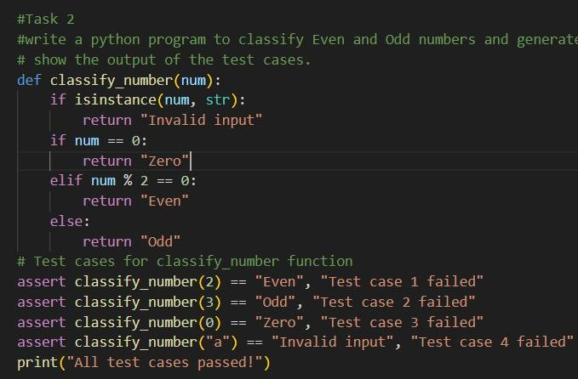
Output:-
Task Description #3 (Palindrome Checker – Apply AI for String Normalization) • Task: Use AI to generate at least 3 assert test cases for a function is_palindrome(text) and implement the function.
- Requirements:
o Ignore case, spaces, and punctuation. o Handle edge cases such as empty strings and single characters.
Example Assert Test Cases: assert is_palindrome("Madam") == True
assert is_palindrome("A man a plan a canal Panama") ==True
assert is_palindrome("Python") == False Expected Output #3:
- Function correctly identifying palindromes and passing all AI-generated tests.
Prompt: write a python program to check whether a palindrome using string Normalization and generate 3 assert test cases for the function is palindrome and show the output of the test cases. show the passing of the test cases. and requirements are ignoring case, spaces ,and punctuation. it handle edge cases as empty string and single character.
Code:-
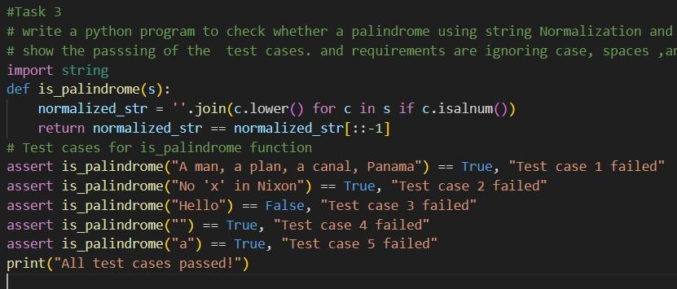
Output:-
Task Description #4 (BankAccount Class – Apply AI for
Object-Oriented Test-Driven Development)
- Task: Ask AI to generate at least 3 assert-based test cases for a BankAccount class and then implement the class.
- Methods:
o deposit(amount) o withdraw(amount) o get_balance()
Example Assert Test Cases: acc = BankAccount(1000) acc.deposit(500)
assert acc.get_balance() == 1500 acc.withdraw(300) assert acc.get_balance() == 1200 Expected Output #4:
- Fully functional class that passes all AI-generated assertions.
Prompt:write a python program to implement a Bank Account class with methods for deposit, withdraw, and check balance. generate assert test cases for the Bank Account class to test the functionality of each method and show the output of the test cases. show the passes of the test cases.
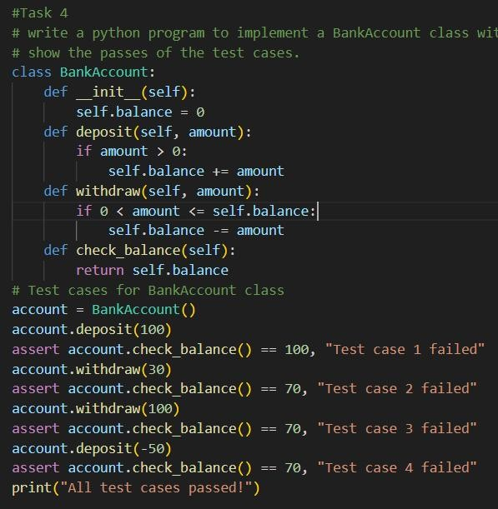
Code:Output:-
Task Description #5 (Email ID Validation – Apply AI for Data Validation)
- Task: Use AI to generate at least 3 assert test cases for a function validate_email(email) and implement the function.
- Requirements:
o Must contain @ and . o Must not start or end with special characters. o Should handle invalid formats gracefully.
Example Assert Test Cases: assert validate_email("user@example.com") == True assert validate_email("userexample.com") == False assert validate_email("@gmail.com") == False Expected Output #5:
• Email validation function passing all AI-generated test cases and handling edge cases correctly.
Prompt:write a python program to implement a email id validator at least 3 assert test cases for the function validate email and show the output of the test cases. show the passing of the test cases. and requirements are it should contain "@" symbol, a valid domain name, and no spaces allowed.
# assert validate_email("user@example.com") == True
# assert validate_email("userexample.com") == False
# assert validate_email("@gmail.com") == False
Code:-
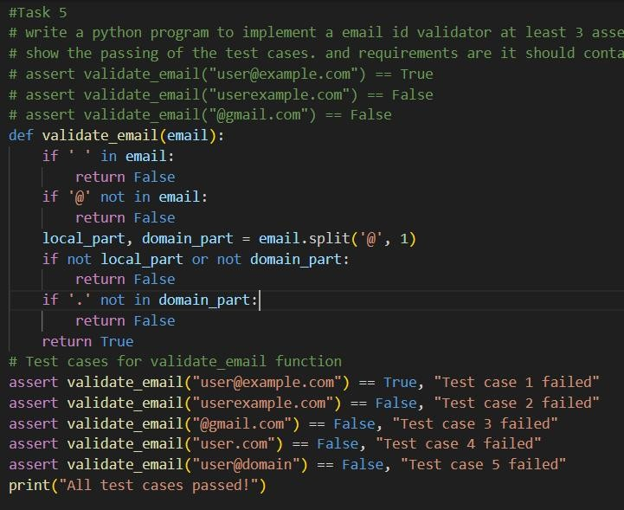
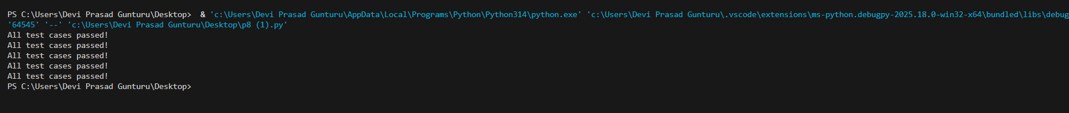
Output:-

